TOPIC 6: BACKTRACKING
Q1. N-Queens Problem Aim:
To place N queens on an N×N chessboard so that no two queens attack each other.

Algorithm:
- Place queen row by row.
- Check column and diagonal safety.
- If safe, place queen and recurse.
- If no safe position, backtrack.
- Print all valid configurations.

Input:
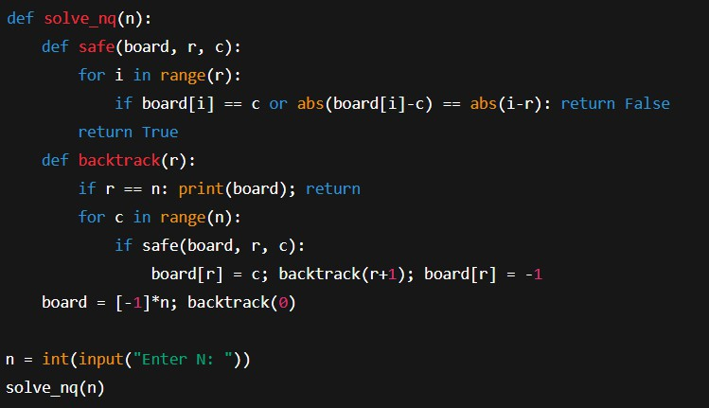

Output:
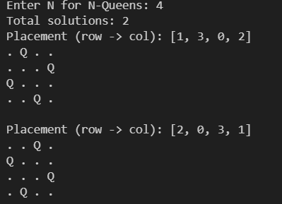
Result: The program displays two valid board configurations for placing 4 queens safely. It confirms that all queens are positioned without attacking each other.

- Search for empty cell.
- Try digits 1–9.
- Check row, column, box validity.
- Recurse to next cell.
- Backtrack if invalid.
Input: Partially filled Sudoku grid.
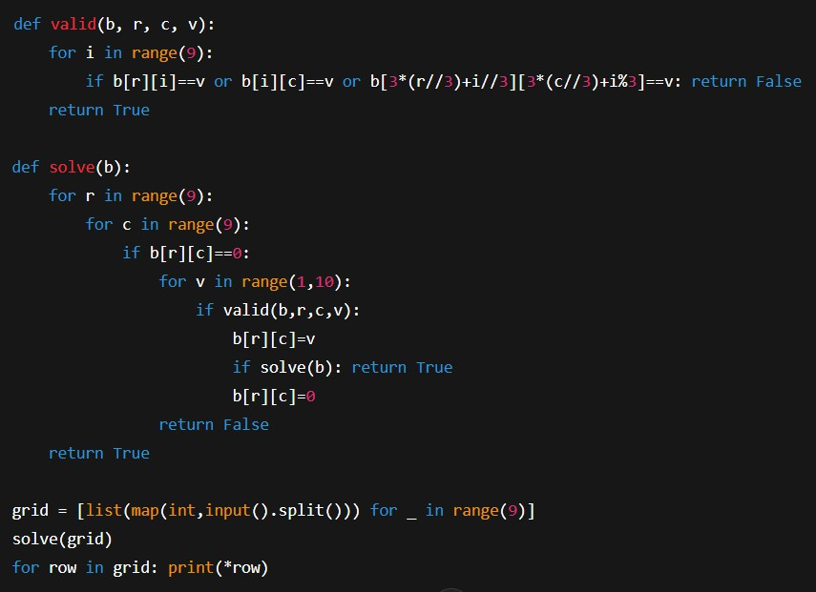
Output: Completed valid Sudoku.
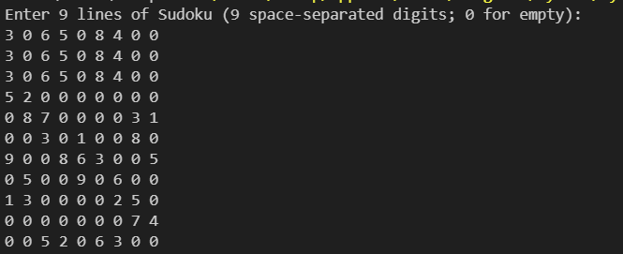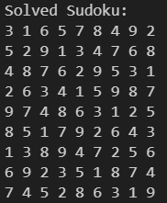

Result: The program fills all empty cells following Sudoku rules. It prints the fully solved and valid Sudoku grid.

- Start at (0,0).
- Move Right/Down if safe.
- Mark visited cells.
- Recurse to destination.
- Backtrack if blocked.
Input: Maze = 2D matrix with 1 as open path.
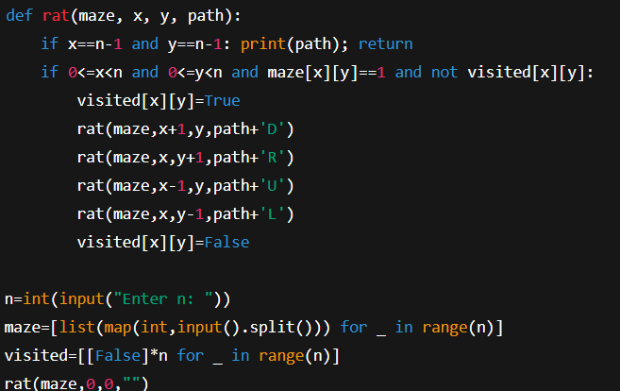
Output: All possible paths.
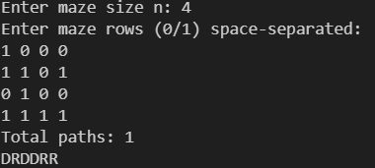
Result: The program lists all possible paths from the start to destination. Each path is printed as a sequence of moves (e.g., DDRR).

To find subsets whose elements sum to a target value.

Algorithm:
- Input set and target sum.
- Include or exclude current element.
- Check if current sum = target.
- Recurse to next element.
- Backtrack after exploring branch.
Input: Set = {2,3,5,6,8,10}, Target = 10
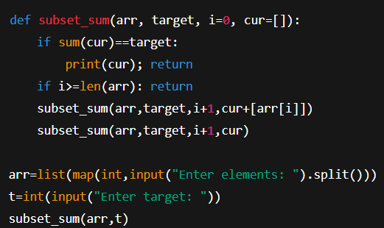
Output: {2,8}, {10}
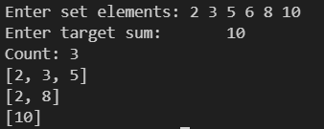
Result: The program prints all subsets whose elements add up to the target sum. Output subsets include {2,8} and {10}.

To find a cycle that visits each vertex exactly once.

Algorithm:
- Start from vertex 0.
- Add next vertex if edge exists.
- Check if vertex already visited.
- Recurse until all vertices covered.
- Close cycle and print result.
Input: Graph adjacency matrix.
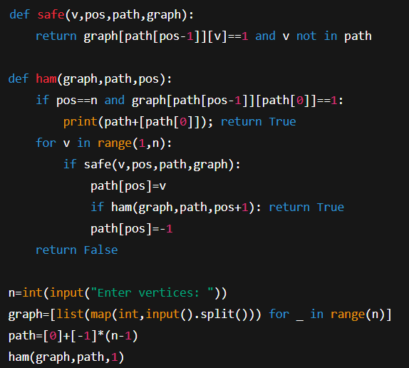
Output: Valid Hamiltonian cycle.
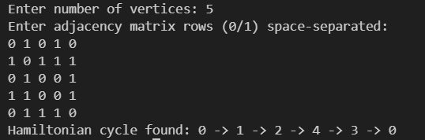
Result: The program finds a Hamiltonian cycle visiting all vertices exactly once. It prints one valid cycle path such as 0 → 1 → 2 → 4 → 3 → 0.

